New Patient Intake Form
Kautz Chiropractic, LLC
First Name ______________________ Middle _____ Last Name ________________________________
Address _____________________________________________________________________________
City ____________________________ State ___________________ Zip Code _____________________
Home Phone (______) _____ - ________________ Work Phone (_____) _____ - __________________
Cell Phone (_____) ______ - __________________ Email _____________________________________
Date of Birth ______ / ______ / _______________ Sex: Male Female
Social Security Number: _____ - _____ - ________ Marital Status: Single Married Other
Employment Status Employed Unemployed Student Other _______________________
Employer Data
Employer ____________________________________________________________________________
Your Occupation ______________________________________________________________________
Emergency Contact
Contact Name ________________________ Relationship to Patient ___________________________
Contact Home Phone (_____) _____ - __________ Cell Phone (_____) _____ - __________________
How did you hear about our office? _______________________________________________________

***Please present insurance card to receptionist to be photocopied. Please supply the insurance policy holder’s birth date if the policy holder is someone other than yourself.
Policy Holder’s Name: ___________________________________________________________________
Policy Holders DOB:_____________________________________________________________________

Medical Conditions: (Check all that apply to you)
Arthritis Cancer Diabetes Heart Disease
Hypertension Psychiatric Illness Skin Disorder Stroke
Osteoporosis Fibromyalgia Asthma Other: _______
Height: _______________________________ Weight: ____________________________________
Surgeries (with date):___________________________________________________________________
_____________________________________________________________________________________
Allergies: _____________________________________________________________________________
_____________________________________________________________________________________
Medications: _________________________________________________________________________
_____________________________________________________________________________________
Social History: (Check all that apply to you)
Drink Alcohol: occasional often never
Cigarettes: <1 pack/day >1 pack/day never
Family History: (Check all that apply to you)
Arthritis: Parent Sibling
Cancer: Parent Sibling
Diabetes: Parent Sibling
Heart Disease: Parent Sibling
Hypertension: Parent Sibling
Stroke: Parent Sibling
Thyroid: Parent Sibling
Other: _________________________________
Review of Systems: (Check all that apply to you)
General: Weight Gain/Loss Loss of Appetite Fevers Weakness Fatigue
Respiratory: Short of Breath Cough Asthma Congestion
Wheezing
Cardiovascular: Chest Pain Palpitations Varicose Veins Swelling
Sweating
Gastroenterology: Nausea Heartburn Diarrhea Constipation
Abdominal Pain Indigestion
Urology: Frequency Painful Urination Discolored Urine Erectile Dysfunction
Ear,Nose,Throat: Dizziness Hearing Loss Nose Bleeds Sinus Infection
Difficulty Swallowing
Eyes: Blurred Vision Double Vision Vision Floaters
Psychiatric: Depression Anxiety High Stress
Dermatology: Rash Flushing Dry Skin Wound
Musculoskeletal: Joint Pain Cramping Muscle Pain Neck Pain
Back Pain Leg Pain Arm Pain Osteoporosis
*Using the key below, indicate on the body diagram where you are experiencing the following symptoms:
N = Numbness B = Burning S = Sharp T = Tingling A = Dull Ache
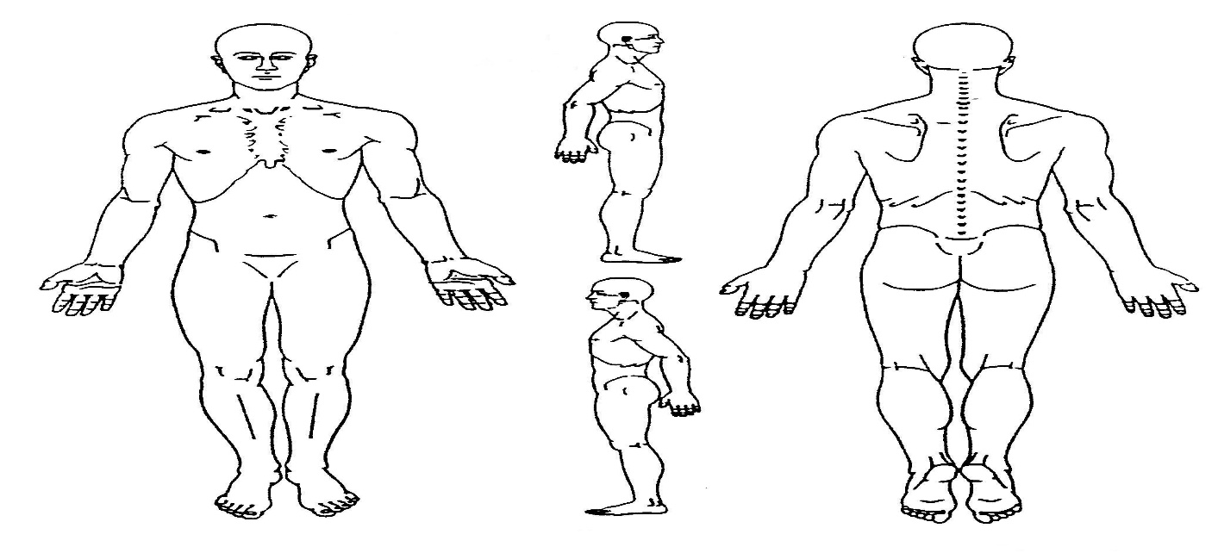Average Pain Intensity:
Last 24 hours: no pain 0 1 2 3 4 5 6 7 8 9 10 worst pain
Past week: no pain 0 1 2 3 4 5 6 7 8 9 10 worst pain
Does anything improve your pain? Yes No If yes, please explain: __________________
When did your symptoms begin? _________________________________________________
Are your symptoms a result of: Motor Vehicle Accident Work Related Accident Other _______
How did your symptoms begin: ___________________________________________________
_____________________________________________________________________________
How often do you experience your symptoms?
Constantly Frequently Occasionally Intermittently
(76-100% of day) (51-75% of day) (26-50% of day) (0-25% of day)
What activities are affected by your symptoms?
Sleep Working Walking Exercising
Housework Sitting Standing Grooming
Other _______ Driving Hobbies/Social Activities

Payment Policy
Thank you for choosing Kautz Chiropractic, LLC as your chiropractic provider. We are committed to providing you with quality and affordable health care. Due to some of the questions our patients have had regarding patient and insurance responsibility for services rendered, we have been advised to develop this payment policy. Please read it, ask any questions you may have, and sign in the space provided below. A copy will be provided to you upon request.
- INSURANCE. We participate in most insurance plans, including Medicare. If you are not insured by a plan we participate with, payment in full for each visit is required until we can verify your coverage. Knowing your insurance benefits is your responsibility, please contact your insurance company with any questions you may have regarding your coverage. If your insurance company requires a referral it is your responsibility to provide us with a referral dated the day of your first visit from your primary care physician prior to your first visit.
- CO-PAYMENT AND DEDUCTIBLES. All co-payments and deductibles must be paid at the time of service. This arrangement is part of your contract with your insurance company. Failure on our part to collect co-payments and deductibles from patients can be considered fraud. Please help us in upholding the law by paying your co-payment at each visit.
- PROOF OF INSURANCE. We must obtain a copy of your most current insurance card to provide proof of insurance. If you fail to provide us with correct insurance information in a timely manner, you may be responsible for the balance of the claim.
- CLAIM SUBMISSION. We will submit your claims and assist you in any way we reasonably can to help get your claim paid. Your insurance company may need you to supply certain information directly. It is your responsibility to comply with their request. Please be aware that the balance of your claim is your responsibility whether or not your insurance pays your claim. Your insurance benefits are a contract between you and your insurance company; we are not party to that contract.
- COVERAGE CHANGES. If your insurance coverage changes, please notify us before your next visit so we can make the appropriate changes to help you receive your maximum benefits.

Our practice is committed to providing the best treatment to our patients. Our prices are representative of the usual and customary charges for our area.

CHIROPRACTIC INFORMED CONSENT TO TREAT
I hereby request and consent to the performance of chiropractic procedures, including various modes of physiotherapy, diagnostic x-rays, and any supportive therapies on me (or on the patient named below, for whom I am legally responsible) by the doctor of chiropractic indicated below and/or other licensed doctors of chiropractic and support staff who now or in the future treat me while employed by, working, or associated with or serving as back-up for the doctor of chiropractic named below, including those working at the clinic or office listed below or any other office or clinic, whether signatories to this form or not.
I have had an opportunity to discuss with the doctor of chiropractic named below and/or with other office or clinic personnel the nature and purpose of chiropractic adjustments and procedures.
I understand and I am informed that, as is with all healthcare treatments, results are not guaranteed and there is no promise to cure. I further understand and I am informed that, as is with all healthcare treatments, in the practice of chiropractic there are some risks to treatment, including, but not limited to, muscle spasms for short periods of time, aggravating and/or temporary increase in symptoms, lack in improvement of symptoms, fractures, disc injuries, strokes, dislocations and sprains. I do not expect the doctor to be able to anticipate and explain all risks and complications, and I wish to rely on the doctor to exercise judgment during the course of the procedure which the doctor feels at the time, based upon the facts then known, is in my best interest.
I further understand that chiropractic adjustments and supportive treatment is designed to reduce and/or correct fixations allowing the body to return to improved health. It can also alleviate certain symptoms through a conservative approach with hopes to avoid more invasive procedures. However, like all other health modalities, results are not guaranteed and there is no promise to cure. Accordingly, I understand that all payment(s) for treatment(s) are final and no refunds will be issued. However, prorated fees for unused, prepaid treatments will be refunded if you wish to cancel the treatment.
I further understand that there are treatment options available for my condition other than chiropractic procedures. These treatment options include, but not limited to, self-administered, over the counter analgesics, and rest; medical care with prescription drugs such as anti-inflammatories, muscle relaxants and painkillers; physical therapy; steroid injections; bracing; and surgery. I understand and have been informed that I have the right to a second opinion and secure other opinions if I have concerns as to the nature of my symptoms and treatment options.
I have read, or have had read to me, the above consent. I have also had an opportunity to ask questions about its content, and by signing below I agree to the above-named procedures. I intend this consent to cover the entire course of treatment for my present condition and for any future condition(s) for which I seek treatment.

MASSAGE CANCELLATION / NO SHOW POLICY
We understand that there are times when you must miss an appointment due to emergencies or obligations for work or family. However, when you do not call to cancel an appointment, you may be preventing another patient from getting much needed treatment. Conversely, the situation may arise where another patient fails to cancel and we are unable to schedule you for a visit, due to a seemingly “full” appointment book.
If an appointment is not cancelled at least 24 hours in advance for a massage you will be charged the full amount. This will not be covered by your insurance company.

APPOINTMENT REMINDER AGREEMENT
I authorize Kautz Chiropractic or Shepherd Chiropractic to send me appointment reminders via text message or voicemail to the phone number listed below.

Patient name__________________________________ Date of birth ___________________________

Phone/Cell number _____________________________

I have read and understood the payment policy, informed consent, massage cancellation policy, appointment reminder agreement and agree to abide by the guidelines.

_______________________________________ _______________________________
Signature of patient or responsible party Today’s Date

Courtney Kautz D.C. CCSP Ron Shepherd D.C., DACBSP Joey Vanduyne D.C.
Kautz Chiropractic, LLC Shepherd Chiropractic PLLC 700 Eagle Ridge Rd
700 Eagle Ridge Rd. 700 Eagle Ridge Rd Le Claire, IA 52753
LeClaire, IA 52753 Le Claire, IA 52753

.

